Create a project

Look at android:theme line in AndroidManfest.xml. This points to @style/AppTheme

Look at styles.xml and find style name = “AppTheme”. Change *Holo* to *Material*.

Although app still runs, compiler is unhappy because it complains that minSdkVersion should be 21. Change the minSdkVersion in build.gradle to 21. Clean and build. The unhappiness goes away.

### How to apply a style

Click a widget (example: button) then click on … beside *style*.

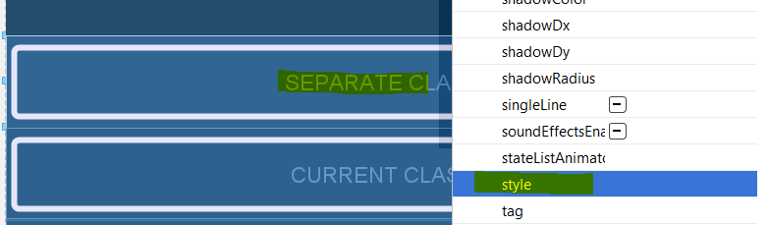

This dialog appears. Choose any style then apply it. You will notice that the style for the widget changes.

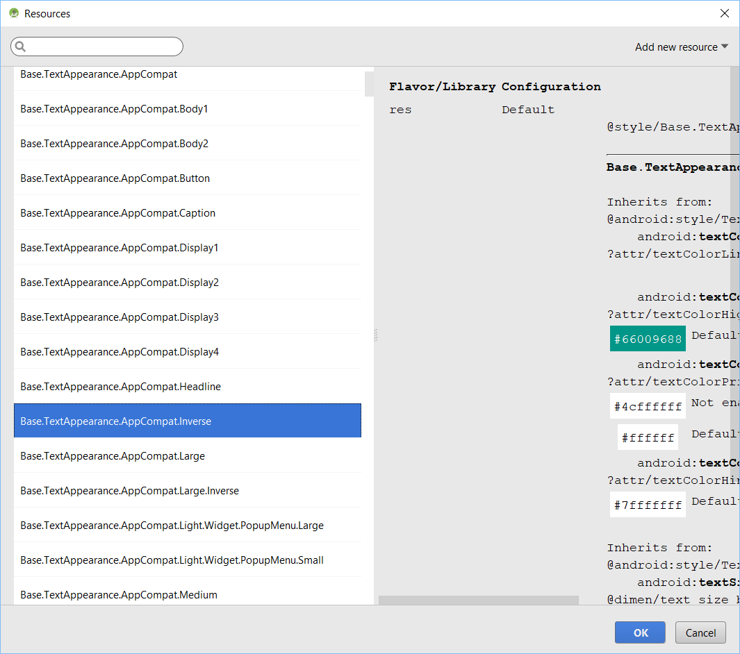

This is what the widget (example: button) may look like:

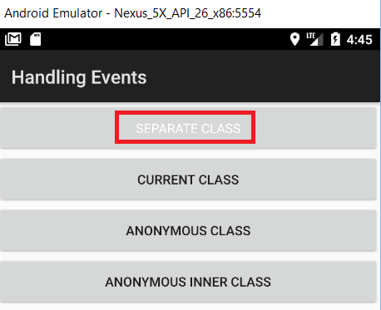

Go into the XML file and delete the style for the widget.

### How to create a custom style sheet

Add the following to the top of the styles.xml file inside <resources>:

<color name="red">#FF0000</color>

<color name="maroon">#800000</color>

<color name="brown">#A52A2A</color>

<color name="firebrick">#B22222</color>

<color name="indigo">#4B0082</color>

<style name="TextView" parent="@android:style/Widget.TextView">

<item name="android:textSize">30sp</item>

<item name="android:textColor">@color/red</item>

</style>

<style name="Button" parent="@android:style/Widget.Button">

<item name="android:textStyle">bold</item>

<item name="android:textSize">20sp</item>

<item name="android:textColor">@color/indigo</item>

</style>

Add the following inside the <style name=”AppTheme” > block:

<item name="android:textViewStyle">@style/TextView</item>

<item name="android:buttonStyle">@style/Button</item>